A Project Report
On

TRAVEL AGENGY: BOOKING AND MANAGEMENT



Undertaken At
Prakash Higher Secondary School,
Bodakdev, Ahmedabad- 380 054

By
Aakanksha Singh
Aarohi Uniyal
Hardee Choudhary

Guided By
Mr. Jatin Shah
(Subject Teacher)

Submitted To
Prakash Higher Secondary School, Ahmedabad-54
(Affiliated to Central Board of Secondary Education)
CERTIFICATE

This to certify that the practical work satisfactorily carried out in the Computer Laboratory during the academic year 2020/2021 and hence recorded in this file is the bonafide work of Master/Miss ______________ of class XII Science.

External
Teacher’s Examiner’s
Signature Signature

Remarks :

Date:

INDEX

- ABOUT PYTHON…….…………………………………………….Pg-04
- ABOUT MYSQL……………………………………………………..Pg-05
- HARDWARE & SOFTWARE………………………………..Pg-06
REQUIREMENTS
- WATERFALL MODEL…………………………………..…….…Pg-07
- SYSTEM FLOW…………………………...............................Pg-08
- SYSTEM DESCRIPTION……………………………………..Pg-09
- ERROR HANDLING…………………………………………….…Pg-10
- DATA DICTIONARY…………………………………………….Pg-12
- SOURCE CODE……………………………………………………….Pg-13
- SCREENSHOTS…………………………………….…..….......Pg-14
- ACKNOWLEDGEMENT……………………………….………Pg-15
- BIBLIOGRAPHY……………………………………………….… Pg-16

ABOUT PYTHON
Introduction
It is widely used general purpose, high level programming language developed by Guido van Rossum in 1991.

It is used for:
Software development, Web development, Scripting, GUI Development and many more applications.

Features of Python
1. Easy to use: Due to simple syntax rule.
2. Interpreted language: Code execution & interpretation line by line.
3. Cross-platform language: It can run on Windows, Linux, and Macintosh etc. equally.
4. Expressive language: Less code to be written as it it express the purpose of the code.
5. Completeness: Support wide range of library.
6. Free & Open Source: Can be downloaded freely and source code can be modify for improvement.
Shortcomings of Python
- Lesser libraries: As compared to other programming languages like C++, Java, and .net.
- Slow language: As it is interpreted languages, it executes the program slowly.
- Weak on Type-binding: It doesn’t pin point on use of a single variable for different data type.

ABOUT MYSQL
MySQL is a fast, easy-to-use RDBMS being used for many small and big businesses. MySQL is developed, marketed and supported by MySQL AB, which is a Swedish company. MySQL is becoming so popular because of many good reasons −
- MySQL is released under an open-source license. So you have nothing to pay to use it.
- MySQL is a very powerful program in its own right. It handles a large subset of the functionality of the most expensive and powerful database packages.
- MySQL uses a standard form of the well-known SQL data language.
- MySQL works on many operating systems and with many languages including PYTHON, PHP, PERL, C, C++, JAVA, etc.
- MySQL works very quickly and works well even with large data sets.
- MySQL is very friendly to PHP, the most appreciated language for web development.
- MySQL supports large databases, up to 50 million rows or more in a table. The default file size limit for a table is 4GB, but you can increase this (if your operating system can handle it) to a theoretical limit of 8 million terabytes (TB).
- MySQL is customizable. The open-source GPL license allows programmers to modify the MySQL software to fit their own specific environments.

HARDWARE AND SOFTWARE REQUIREMENTS

- HARDWARE SPECIFICATION
- MEMORY : 512 MB
- MICROPROCESSOR: Dual Core 1.5 Ghz and above
- HARD DISK: 40 GB
- PRINTER: HP Laser printer
- KEYBOARD AND MOUSE: Qwerty Keyboard and Optical Mouse
- MONITOR: 15 inch CRT, LED or LCD

- SOFTWARE SPECIFICATION
- OPERATING SYSTEM: WINDOWS 7 and above.
- FRONT END: Python
- BACKEND: MySql
- PYTHON MYSQL CONNECTOR

WATERFALL MODEL
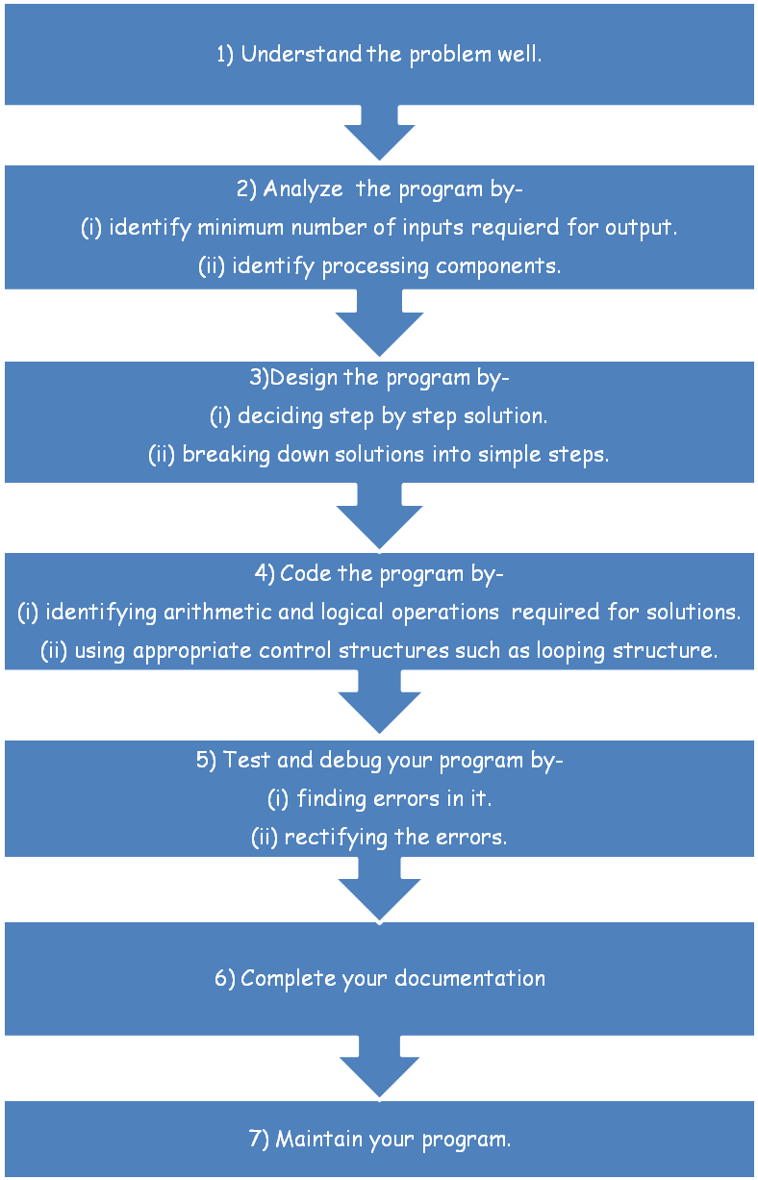

SYSTEM FLOW

Musafirs
Main Menu

Schemes, date, form, billing
Enter id and pass
Sign In
Book a tour

Update tour
No. of people, date, mode of transport

Delete
Delete Acc., booking

Display

Sign out
Musafirs
Schemes

Create id and pass.
Sign Up
Main Menu

End of the process.
Exit

SYSTEM DESCRIPTION

The Travel agency management and booking system is designed for “Safarnama Tours” to replace their existing manual, paper based system. This system targets to provide complete solution for Travel services. A similar System can be used in any Booking agency for maintaining user details and their booking details. It simplifies and integrates the tedious booking procedure into one integrated software application.

This project starts up with a welcome screen and proceeds to the main menu. The main menu has several options that are listed below –
  - SIGN IN (LOGIN): If the user has already created the login credentials, i.e., is a frequent “MUSAFIR” then the user can login using those credentials.

  - SIGN UP (REGISTER): If the user has not created login then the user can create a one using this option.

  - Exit: Can come out of the project.

Once the user has successfully logged in then the menu below will be displayed:

  - BOOK a TOUR: Under this option the user can select a tour from a wide variety of available tours with fun activities.
- Schemes: “Musafir” can select from a number of diverse places to travel and even opt for preferred dates of travelling.
- Form: The “Musafir” can fill out the details and give extra instructions and even select mode of transport.
- Billing: A detailed bill copy of all the expenses is provided.

  - UPDATE PRE-BOOKED TOUR: Under this option the user can update tour details.
- After updating of either the scheme, date of travelling, mode of transport or number of people a renewed bill is displayed.

  - DELETE TOUR/ACCOUNT: Under this option the user may delete his/her booked trip or delete his account.

  - DISPLAY: Under this option the “MUSAFIR” and see his travel details.
ERROR HANDLING

Syntax Errors
Error caused by not following the proper structure (syntax) of the language is called syntax error or parsing error.
Let's look at one example:
if a < 3
print(“Granted”)
The error is in
if a < 3
It should be
if a < 3:
Semantic Errors
These errors occur when statements are not meaningful. Semantics refers to the set of rules which give the meaning of a statement.
For instance,
x * y = z;
This statement will result into a semantic error as an expression cannot come on the left side of an assignment statement.

Run-time Errors
A run time error occurs during the execution of a program. It is caused of some illegal operation taking place or non-availability of desired or required condition for the execution of the program.
For instance, if a program goes into infinite loop or wrong value(of different data type other than required) is entered.

Logical Errors
A logical error is that error which causes a program to produce incorrect or undesired output.
For instance, if we are trying to print the table of 3 and we specify the condition of the loop – a == 10 then the loop will not be executed even once.

Errors we encountered during the making of this project:
Sr.  No. | Error message received | Reason due to which error was received
1. | NameError | Raised when an identifier name is not found.
2. | KeyError | Raised when a dictionary key is not found in the set of existing keys.
3. | Import Error | Raised when an import statement fails to find the module definition.
4. | ValueError | Raised when a built-in operation or function receives an argument with an inappropriate value.
5. | IndexError | Raised when a sequence subscript or index is out of range.

DATA DICTIONARY

Sr.  No. | Field  Name | Type | Description
1 | Musafirs | Mysql Table | This table stores the name and mobile number of the “Musafir”.
2 | Schemes | MySQL Table | The table stores the information about the “Musafir’s” booked tour and travelling options.
3 | Bigfunc() | User-defined function | This function is a parent function and includes important sub functions like form, billing and even the basic tour selection function.
4 | mysql.connector | Library/Module | This contains the functions required for mysql-python connectivity like connect(), cursor() etc.
5 | mobno | int | It stores the 10 digit mobile number of the “Musafir”
6 | sc | list | This list stores the schemes
7 | choice | int | This variable stores value of the choice for sign up, sign in or exit.
8 | price | Dictionary | This will store the individual preliminary charges of each tour. To this amount extra expenses are added.
9 | mode | Dictionary | This will store the details of plausible mode of transport.

SOURCE CODE
#project work

#establishing connectivity
import mysql.connector
c=mysql.connector.connect(host="localhost",user="root",passwd="asdfg",charset="utf8",database="comp_project")
mycur=c.cursor()
price={1:6700,2:5000,3:9000,4:7300}

#function1 - to display schemes
def scheme():
myfile=open(r"C:\Users\DELL\Desktop\Aarohi\scheme heading.txt","r")
string=myfile.read()
print(string)

#function2 - detailed scheme description
def scheme_no(x):
while True:
if x==1:
myfile=open(r"C:\Users\DELL\Desktop\Aarohi\scheme1.txt","r")
string=myfile.read()
print(string)
break
elif x==2:
myfile=open(r"C:\Users\DELL\Desktop\Aarohi\scheme2.txt","r")
string=myfile.read()
print(string)
break
elif x==3:
myfile=open(r"C:\Users\DELL\Desktop\Aarohi\scheme3.txt","r")
string=myfile.read()
print(string)
break
elif x==4:
myfile=open(r"C:\Users\DELL\Desktop\Aarohi\scheme4.txt","r")
string=myfile.read()
print(string)
break

#Function3 - Form
def form(schemeno):
name=input("Enter your name\n ")

while True:
try:
age=int(input("Enter your age\n"))
break
except:
print("Invalid input\n")
continue

while True:
mobn=input("Enter registered mobile number\n")
if len(mob)==10:
mobno=int(mob)
break
else:
print("Invalid mobile number.Enter again.\n")
continue
print("""MODE TO TRANSPORT:

1. Railway(rajdhani)
a - 3AC train journey
b - 2AC train journey

2. Via flight\n""")
while True:
mode=input("Enter the mode of travelling you prefer(eg: 1a, 1b, 2)\n")
mode=mode.lower()
if mode=="1a" or mode=="1b" or mode=="2":
break
else:
print("Invalid input.enter again\n")
continue

while True:
gender=input("Gender( F / M / OTHER )\n")
gender=gender.lower()
if gender != "f" and gender != "m" and gender != "other" :
print("Invalid input\n")
continue
else:
break

while True:
group=input("Are you travelling in a group?(yes/no):\n")
group=group.lower()
if group=="yes":
num=int(input("Number of people travelling:\n"))
break
elif group=="no":
num=1
int(num)
remarks=input("Do you have any specification? if no fill \"none\"\n")
break
else:
print("Invalid input\n")
continue

while True:
date=input("From the given dates in schemes select trip number(corresponding date of travel will be booked)\n")
if date>='1' and date<='5':
break
else:
print("Invalid input. Enter agaian")
continue
break
string="INSERT INTO schemes(mobno,schemeinfo,num,mode,date) VALUES({},{},{},'{}','{}')".format(mobno,schemeno,num,mode,date)
mycur.execute(string)
c.commit()
return(num,mode)

#function4 - billing
def bill(x,num,mode):
per=price[x]
int(per)
num1=num
print(" Sr.no criteria amount")
print(" 1. Person charge - RS. ",per,"*",num1)
amt1=per*num1
if mode=="1a":
print(" 2. Transport charge Rs. 1295*",num1)
amt2=1295*num1
elif mode=="1b":
print(" 2. Transport charge Rs. 2100*",num1)
amt2=2100*num1
else:
print(" 2. Transport charge Rs. 3000*",num1)
amt2=3000*num1
print(" ---------------------------------------------------------------------------------------------\n")
print("\n GST: 5% of total\n")
total=amt1+amt2
gst=total+((5/100)*total)
print("---------------------------------------------------------------------------------------------")
print(" SUBTOTAL= Rs.",gst)

#function5- updating existing details in databases
def update(x):
mycur.execute("select * from schemes where mobno={}".format(x))
data=mycur.fetchall()
mode1=data[0][3]
schemeno=data[0][1]
num=data[0][2]
while True:
choice=input("Do you want to change the mode of transport? (yes/no)\n")
if choice=="yes":
print("""MODE TO TRANSPORT:

1. Railway(rajdhani)
a - 3AC train journey
b - 2AC train journey

2. Via flight\n""")
mode1=input("Enter desired mode of transport\n")
if mode1=="1a" or mode1=="1b" or mode1=="2":
string="update schemes set mode='{}' where mobno={}".format(mode1,x)
mycur.execute(string)
c.commit()
break
else:
print("Invalid input.enter again\n")
continue
elif choice=="no":
break
else:
continue

while True:
choice=input("Do you want to change the number of people travelling? (yes/no)")
if choice=="yes":
while True:
try:
num=int(input("Enter number of people travelling\n"))
break
except:
print("Invalid input. Enter again\n")
continue
string="UPDATE schemes SET num={} WHERE mobno={}".format(num,x)
mycur.execute(string)
c.commit()
break
elif choice=="no":
break
else:
continue

while True:
choice=input("Do you want to change the scheme (and/or) date of travelling? (yes/no)\n")
if choice=="yes":
scheme()
while True:
try:
schemeno=int(input("Enter number coressponding to scheme you want to select\n"))
if schemeno>=1 and schemeno<=4:
scheme_no(schemeno)
break
except:
print("Invalid input. Enter again\n")
continue
while True:
date=input("From the given dates in schemes select trip number(corresponding date of travel will be booked)\n")
if date>='1' and date<='5':
break
else:
print("Invalid input. Enter agaian")
continue
break
string="UPDATE schemes SET date='{}', schemeinfo={} WHERE mobno={}".format(date,schemeno,x)
mycur.execute(string)
c.commit()
break
elif choice=="no":
break
else:
continue

print("Your updated bill is as follows-\n")
bill(schemeno,num,mode1)

#function 6- delete records
def delete(x):
while True:
print("""1. Do you wish to cancel your booking?
2. Do you wish to deactivate your \"MUSAFIR\" account?
(account deactivation cancels all your booked tours)
3. Exit""")
choice=input("Enter your choice (1/2)")
if choice=="1":
st="delete from schemes where mobno={}".format(x)
mycur.execute(st)
c.commit()
break
elif choice=="2":
st1="delete from schemes where mobno={}".format(x)
st2="delete from musafirs where mobno={}".format(x)
mycur.execute(st1)
c.commit()
mycur.execute(st2)
c.commit()
break
elif choice=="3":
break
else:
print("Invalid input. Enter again")
continue

#function 7- display records
def display(x):
sc=["Himalayan Trek","White Water Rafting","Seven Sisters","Kerala"]
date=[["2-3-20 to 6-3-20", "15-3-20 to 20-3-20","8-4-20 to 12-4-20","7-5-20 to 11-5-20","26-5-20 to 30-5-30"],
["25-3-20 to 28-3-20","02-4-20 to 05-4-20","23-5-20 to 26-5-20","17-6-20 to 20-6-20", "27-6-20 to 30-6-20"],
["18-3-20 to 28-3-20","20-4-20 to 12-4-20","16-5-20 to 26-5-20","17-6-20 to 27-6-20","20-6-20 to 30-6-20"],
["22-3-20 to 28-3-20","02-4-20 to 08-4-20","24-5-20 to 30-5-20","17-6-20 to 23-6-20","24-6-20 to 30-6-20"]]
mode={'1a':"3 Tier AC",'1b':"2 Tier AC",'2':"Flight"}

st="select * from schemes where mobno={}".format(x)
mycur.execute(st)
data=mycur.fetchall()
if mycur.rowcount==0:
print("You don't have any active trips")
else:
p=data[0][1]
t=int(p)
schemeinfo=sc[t-1]
d=data[0][4]
e=int(d)
tour=date[t-1][e-1]
mode1=data[0][3]
print("mobile no.: ",data[0][0])
print("number of people: ",data[0][2])
print("tour: ",schemeinfo)
print("mode: ",mode[mode1])
print("date: ",tour)

#function 8- function call
def bigfunc(x):
while True: #1
choice=input(""" Select number coressponding to your choice
--------------------------------------------

1. Book a tour
2. Update details for tour
3. Delete prebooked tour/account
4. View your trip summary
5. Exit\n""")

if choice=="1":

while True:#2
scheme()
while True:
try:
schemeno=int(input("Enter number corresponding to the scheme you want to select\n"))
if schemeno>=1 and schemeno<=4:
scheme_no(schemeno)
break
except:
print("Invalid input. Enter again\n")
continue

choice2=input("Do you want to join the trip? (yes/no/exit)\n")
if choice2=="yes":
print("Please fill in the following form\n")
num,mode=form(schemeno)
print("Thankyou for joing our adventure tour !!\n YOUR BILL IS AS FOLLOWS\n")
bill(schemeno,num,mode)
print(" THANKYOU!!!!")
break
elif choice2=="no":
continue
elif choice2=="exit":
break# to come out of 2
else:
print("Invalid Input. Enter again")
continue
break# this break is to come out of 1
continue# this is to re print 1

elif choice=="2":
update(x)
continue
elif choice=="3":
delete(x)
print("Your desired record has been successfully deleted.")
continue
elif choice=="4":
display(x)
continue
elif choice=="5":
break# to come out of loop
else:
print("Invalid choice.")
continue
break# to terminate program

#main function

myfile=open(r"C:\Users\DELL\Desktop\Aarohi\display.txt","r")
string=myfile.read()
print(string)

while True:
while True:
try:
musafir=input("Are you a frequent musafir?(yes/no). If not sign up to avail schemes.\nOr input exit to leave\n")
if musafir == 'yes' or musafir=='no' or musafir=='exit':
break
else:
continue
except:
print("Invalid choice. Enter again.\n")
continue

if musafir=='no':
#registration
mname=input("Enter your name.\n")
while True:
mob=input("Enter 10 digit registered mobile number\n")
if len(mob)==10:
mobno=int(mob)
break
else:
print("Invalid mobile number.Enter again.\n")
continue
string="INSERT INTO musafirs(mobno,mname) VALUES({},'{}')".format(mobno,mname)
mycur.execute(string)
c.commit()

#scheme display
print("\n -----------------------------------------------------")
print(" Now you a registered musafir with safarnama tours !!!")
print(" -----------------------------------------------------\n")

bigfunc(mobno)

elif musafir=="yes":
mycur.execute("select mobno from musafirs;")
data=mycur.fetchall()
l=len(data)
while True:
mob=input("Enter 10 digit registered mobile number\n")
if len(mob)==10:
mobno1=int(mob)
for i in range(l):
lst=list(data[i])
lst2=lst[0]
if mobno1 == lst2:
bigfunc(mobno1)
break
else:
continue
else:
print("Not a registered musafir. Sign up")
break
else:
print("Invalid input.Enter again")
break
break
continue
elif musafir=='exit':
break
break
SCREENSHOTS

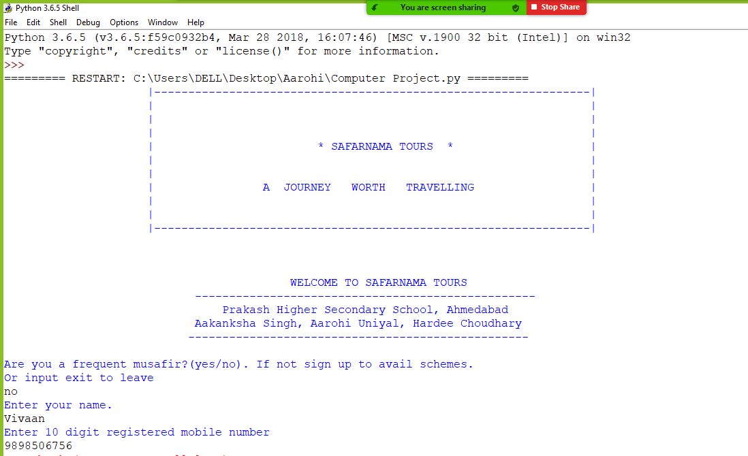
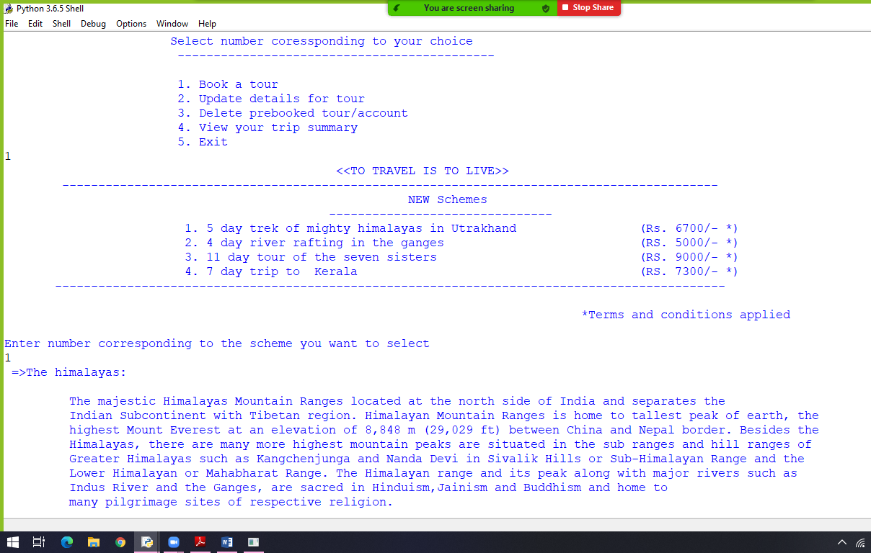
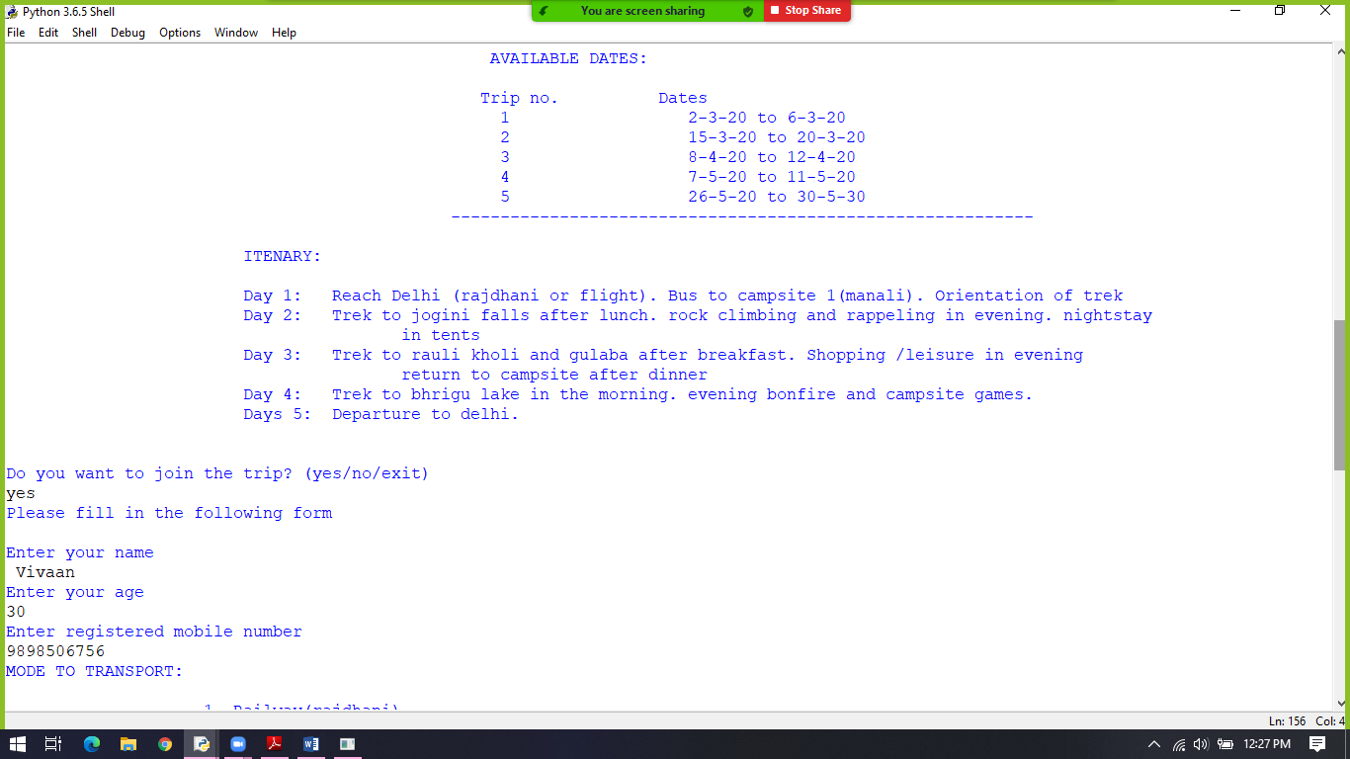
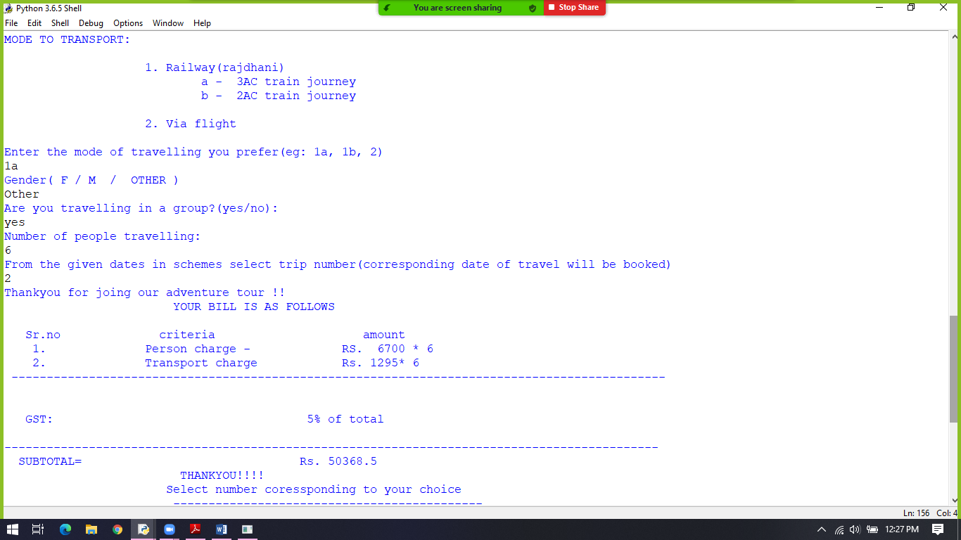
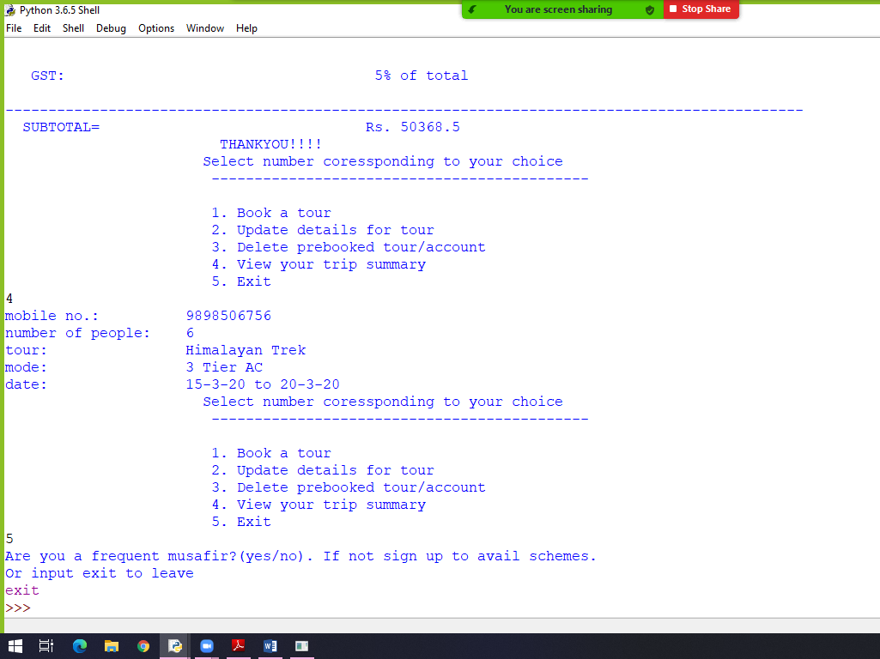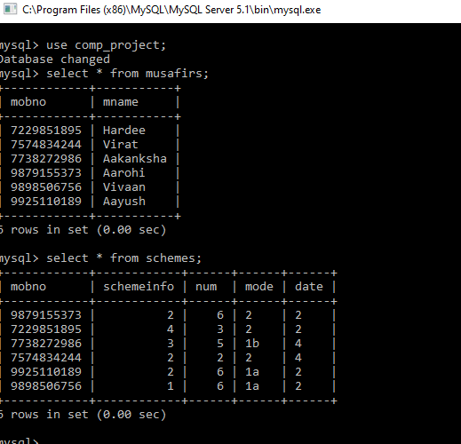
ACKNOWLEDGEMENT

My foremost and profound gratitude goes to Mr. JATIN SHAH, my computer science teacher, for his proficient and enthusiastic guidance and encouragement. The suggestions given by him undoubtedly helped in supplementing my thoughts in the right direction for attaining the desired objective.

My heartfelt gratitude also goes to Director, Principal and all the faculty members of PRAKASH HIGHER SECONDARY SCHOOL, AHD-54 who have contributed directly or indirectly towards the successful completion of this project.

Last but not the least I would like to thank my parents for providing me with the resources which enabled me to put up such a project. I would also like to thank my project partners for their indispensible co-operation.
BIBLIOGRAPHY

Our project on ”Travel Agency” would not have been accomplished without reference from the following :
- SUMITA ARORA (CBSE class XII text book as per NCERT syllabus)
- www.google.com

